Rotherwood
Farming
Hold their 2nd on farm APR bull Helmsman auction sale
Offering 18 2 year old and 3 3 year old bulls
To be held on the property “Rotherwood”
342A Victoria Valley Rd, Ouse at 1pm 22rd August 2013
Inspection:11.30am (bbq & refreshments available)
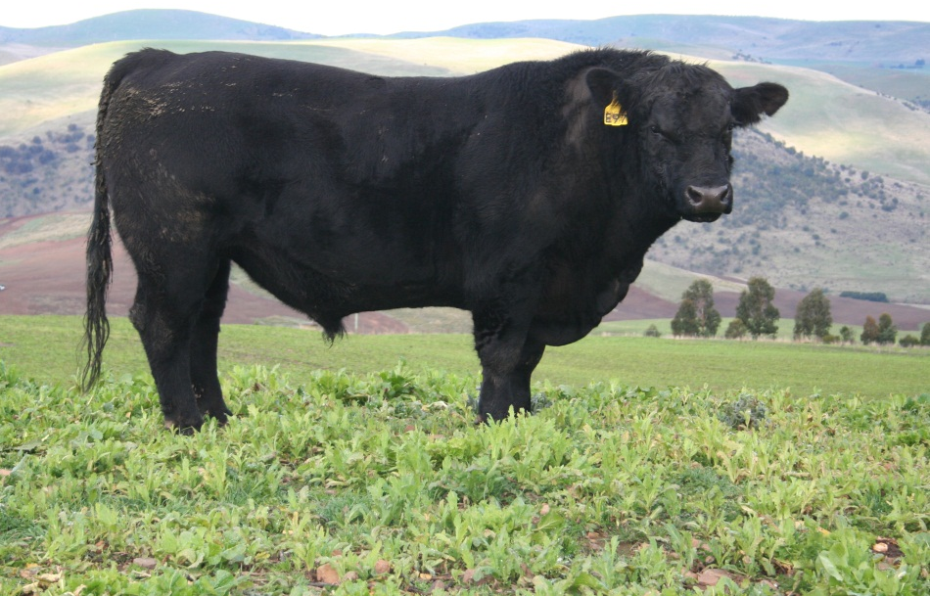
www.rotherwood.net.au
All bulls vaccinated for BVDV and 7 in1 plus MN1 Certification and EU accredited
Contact: Bernard Brain- 6287 1309 or 0428 871 309 Roberts Ltd: Mike Lang- 0408 146 0223
Helen Sproule-62881542 or 0448 871 313 Tim Woodham- 0418 323 425
Jock Gibson- 0418 13359

History of the “Rotherwood” herd:
The herd began in the late 1950’s with 26 heifers bought from “Glenelg” Gretna. In 1963 we started weighing calves, calculating weight ratios, and culling cows whose calves under-performed- we were probably the first Angus herd in Tasmania to do performance recording. Over the next few years sires were purchased from Tasmania, Victoria and New Zealand with variable results. Some performed well, but others not as well as home –bred sires. Others had to be culled due to their foot problems along with their progeny.
In the early 1970’s an Agricultural Officer suggested setting up a nucleus breeding scheme; with 6 breeders suppling their best heifers to the nucleus and receiving a set ratio of bulls in return. Rotherwood was chosen to host the nucleus herd. The aim was to have a regular supply of bulls of the type the members desired-which would improve their herds, at a reasonable cost. The bulls to be used in the nucleus, or supplied, were chosen at a meeting in June, when the new heifers arrived. This worked well for 33 years until it was wound up due a drop in the number of herds, due to owner retirement, and property or herd sale, when the gene pool became too small. It had initially been 2000 cows.
The herd enrolled in Breedplan from the beginning, as an Angus Performance register herd. At the time our 200 and 600day weight EBV’s were about 20% above breed average until the influence of North American genetics occurred. Our aim is to keep birth weights low, while maximizing 600 day weights with improved muscling and keeping our reputation for docile cattle with good conformation. Surplus cows and heifers(EU accredited) are sold at the Powranna autumn commercial cattle sale.
After many years selling bulls privately we decided to move to a helmsman auction system last year. We felt that it would provide the fairest method of selling bulls by auction. The first sale went well for us and were happy with the type of auction system that we used, as it gave prospective purchasers time to go back and look at the bulls during the auction, and change their preferred animal if so desired.

Relevant Terms:
AMFU, CAFU, and NHFU-untested for the genetic disorders but believed to be free.
Calving ease direct (CEM or CEdir) and
Calving ease Daughters (CED or CEDtrs) -genetic estimate of ease of dam or daughter as 2yo heifers to calve without assistance
Birth weight (Bwt) - Estimates of the genetic differences between animals in calf birth weight.
200 day weight- Estimates of the genetic differences between animals in liveweight at 200 days of age.
400 day weight- Estimates of the genetic differences between animals in liveweight at 400 days of age.
600 day weight- Estimates of the genetic differences between animals in liveweight at 600 days of age.
Mature weight (Mwt) - Estimates of the genetic differences between animals in cow weight at 5 years of age.
Milk- Estimates of the genetic differences between animals in milk production, expressed as variation in 200-day weight of daughter's calves.
Scrotal size (SS) - Estimates of the genetic differences between animals in scrotal circumference at 400 days of age.
Days to calving (DOC)- Estimates of the genetic differences in female fertility, expressed as the number of days from the start of the joining period until subsequent calving.
Carcase weight(Cwt) - Estimates of the genetic differences between animals in carcase weight, adjusted to 650 days of age.
Long fed/CAAB $index (LF) - Estimates of the genetic differences between animals in net profitability per cow joined for a high fertility self-replacing commercial Angus herd in temperate Australia targeting pasture grown steers with 270 day feedlot finishing period for the high quality, high marbled Japanese export market. Steers are assumed marketed at 740 kg live weight (420 kg HSCW and 25 mm P8 fat depth) at 26 months of age. Significant emphasis is placed on marbling and 600 day growth.
Heavy grass fed steer $index (HG) - Estimates of the genetic differences between animals in net profitability per cow joined for a self-replacing Angus herd in temperate Australia that sells heavy grass fed steers for markets like the EU and light grass fed Jap Ox Steers are assumed marketed at 600kg live with (300 kg HSCW and 15mm P8 fat depth) at 22 months of age. Emphasis is placed on growth and carcase yield while maintaining fertility and marbling.
Short fed domestic $index (SF) - Estimates of the genetic differences between animals in net profitability per cow joined for a high fertility self-replacing commercial Angus herd selling feeder steers and heifers for the short fed domestic feedlot trade. Steers are assumed marketed at 445 kg live weight (245 kg HSCW and 10 mm P8 fat depth) at 15 months of age. Emphasis is placed on growth to 400 days and high carcase yield while maintaining fertility and marbling.
Terminal $index (TI)- Estimates of the genetic differences between animals in net profitability for a commercial crossbred herd where no animals are kept for breeding and targeting pasture grown steers and heifers with a 100 day feedlot finishing period. Progeny are assumed marketing at 600kg live weight (325 kg HSCW and 17mm P8 fat depth) at 23 months of age. Emphasis is on growth and carcase yield with no weighting placed on calving ease, female fertility or milk.
Accuracy (Acc)- Provides an indication of the reliability of an EBV. As more performance information becomes available on an animal (or it's progeny, or relatives) then the accuracy of it's EBVs for particular traits will increase.

RECESSIVE GENETIC CONDITION
INFORMATION FOR BULL BUYERS
This is information for bull buyers about the undesirable genetic conditions, Arthrogryposis
Multiplex (AM), Neuropathic Hydrocephalus (NH) and Contractural Arachnodactyly (CA).
Putting Undesirable Genetic Recessive Conditions in Perspective
All breeds of cattle, in fact all mammals including humans, have undesirable genetic
conditions. Fortunately, advances in molecular genetics have facilitated the development of
DNA tests for their management. Angus Australia is at the forefront of development of
strategies to manage undesirable genetic conditions and Angus members are leading the
industry with their uptake of this technology.
What are AM, NH and CA?
Arthrogryposis means 'curved or hooked joints'. Multiplex indicates there are multiple
abnormalities associated with the condition. Animals with the NH condition have a large
head. Both AM and NH affected calves are not born alive. Whilst; calves affected by CA are
born alive and can reproduce, muscle contractures restrict the movement of joints,
particularly in the hind legs. Abnormal muscle contracture decreases dramatically as a calf
ages, while muscle development always remains poor.
How are the conditions inherited?
Research in the U.S. and Australia indicates that AM, NH and CA are simply inherited
recessive conditions. This means that a single pair of genes controls the condition. For this
mode of inheritance two copies of the undesirable gene need to be present before the
condition is seen; in which case you may get an abnormal calf. A more common example of
a trait with a simple recessive pattern of inheritance is black and red coat colour.
Animals with only one copy of the undesirable gene (and one copy of the normal form of the
gene) appear normal and are known as “carriers”.
What happens when carriers are mated to other animals?
Carriers, will on average, pass the undesirable gene form to a random half (50 %) of their
progeny.
When a carrier bull and carrier cow is mated, there should be a 25% chance that the progeny
produced will have two normal genes. There should be a 50% chance that the mating will
produce a carrier. However, there could be a 25% chance that the progeny have two copies
of the undesirable gene.
Key point: The number of reported observations of AM, NH and CA calves is very
low and there is certainly no need for panic.
Key point: With today’s DNA tools undesirable genetic conditions can be managed!
If animals tested free of the undesirable gene are mated to carrier animals the condition will
not be expressed at all. All calves will appear normal, but approximately half (50%) could be
expected to be carriers.
How is the AM and NH status of animals reported?
A DNA-based test has been developed that can be used to determine whether an animal is a
carrier or free of the AM, NH or CA gene.
Angus Australia uses sophisticated software to calculate the probability of (all untested)
animals to be a carrier. The software uses the test results of any relatives in the calculations
and the probabilities may change as new results for additional animals become available.
The genetic status of animals is being reported using five categories:
AMF Tested AM free
AMFU Based on pedigree AM free – Animal has not been tested
AM__% _% probability the animal is an AM carrier
AMC Tested AM-Carrier
AMA AM-Affected
For NH and CA, simply replace AM in the above table with NH or CA.
Registration certificates and the Angus Australia (AA) web-database display these codes.
This information is displayed on the animal details page and can be accessed by conducting
an “Animal Search” from the Angus website or looking up individual animals listed for sale in
a sale catalogue.
Implications for Commercial Producers
Your decision on what genetic condition statuses are acceptable will depend on the genetics
of your cow herd (which bulls you previously used), whether you have a straightbreeding or
crossbreeding enterprise and whether some female progeny will be retained as breeders.
Angus Australia seedstock breeders are being proactive and transparent in managing these
genetic conditions, endeavouring to provide the best information available. The greatest risk
to the commercial sector from undesirable genetic recessive conditions comes from
unregistered bulls with unknown genetic background. The DNA testing that Angus Australia
seedstock producers are investing in provides buyers of registered Angus bulls with
unmatched quality assurance.
For further information: Carel Teseling 02 6773 4602.
Key point: For the condition to be expressed the undesirable gene needs to be
present on both sides of the pedigree and both the sire and dam need to be a
carrier.
Key point: The genetic status of an animal is subject to change and will be reanalysed
And adjusted each week as DNA test results of relatives are received.

Tag G3 TDG G3
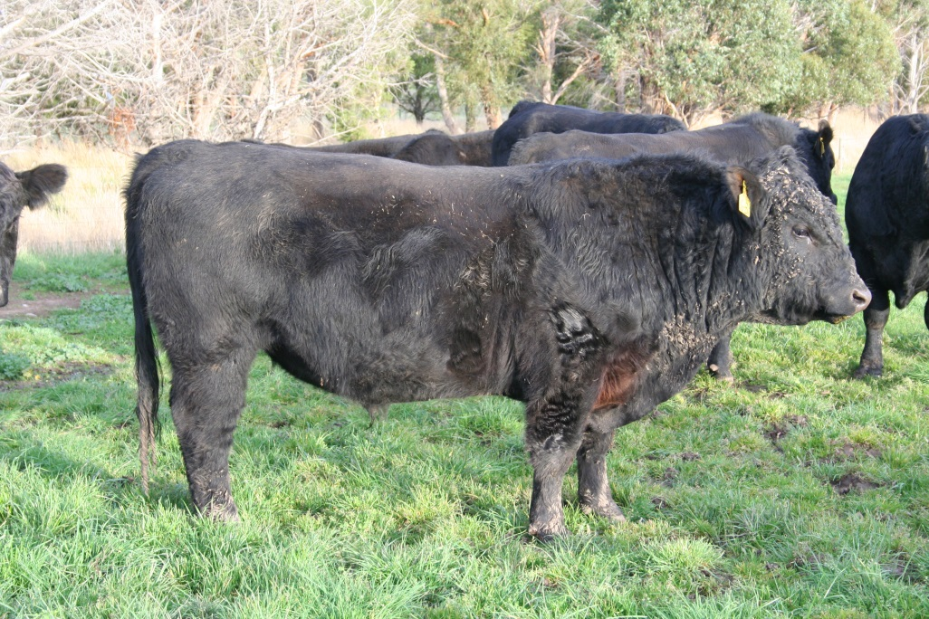
Price………… Purchaser……………………….Tag G4 TDG G4
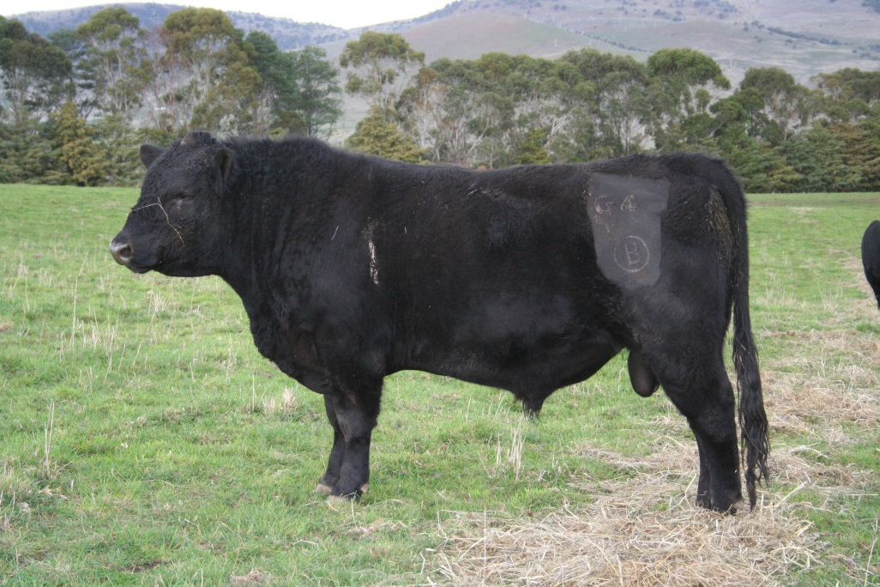
Price………… Purchaser……………
TDG G11 TDG G11
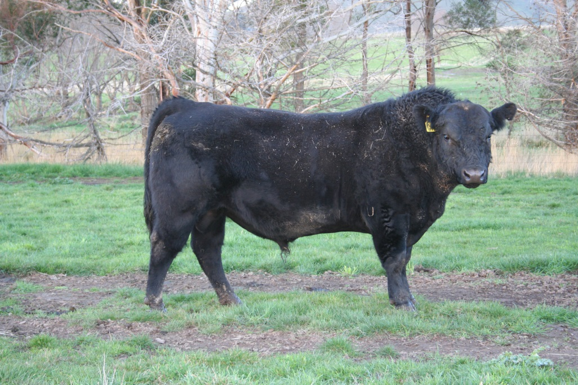
Price………… Purchaser……………………….Tag G 17 TDG G17
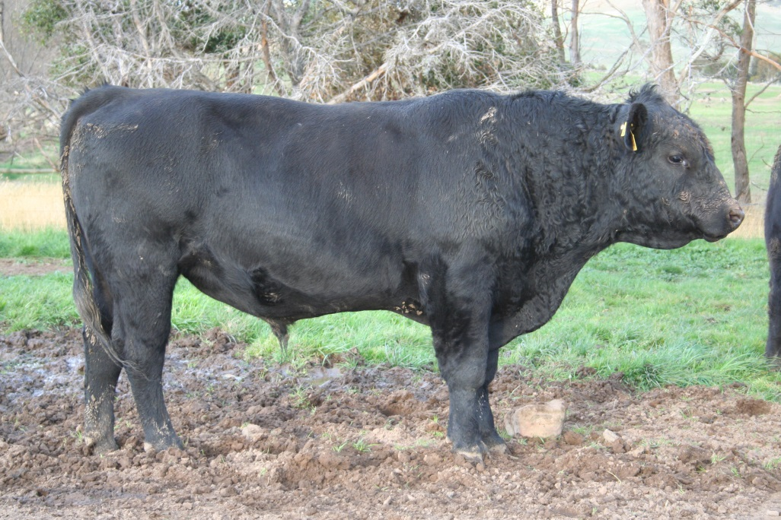
Price………… Purchaser……………………….
Tag G31 TDG G31
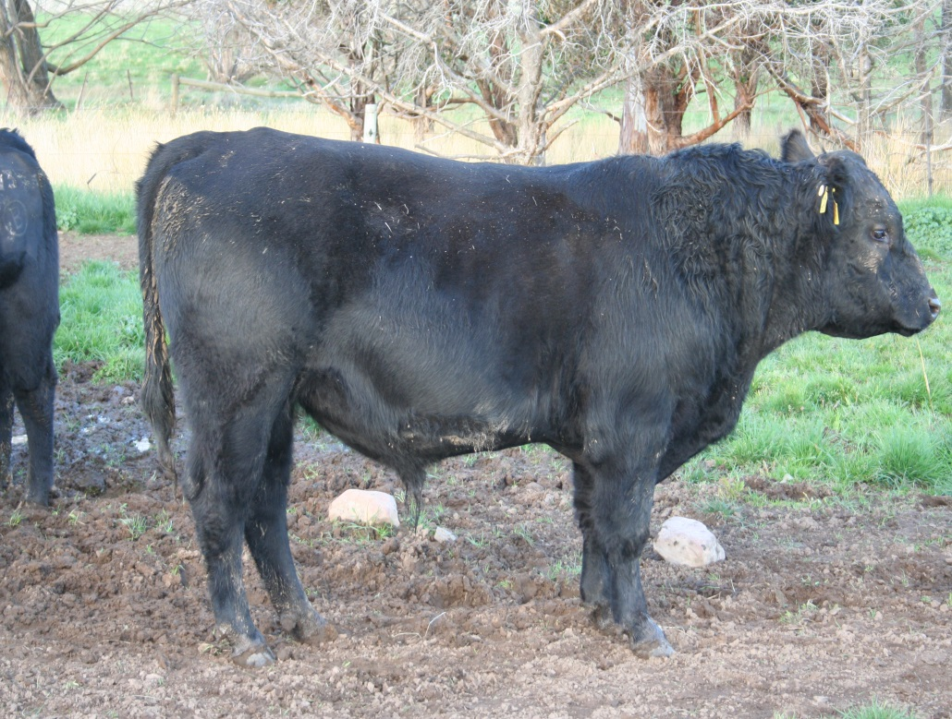
Price………… Purchaser……………………….Tag G32 TDG G32
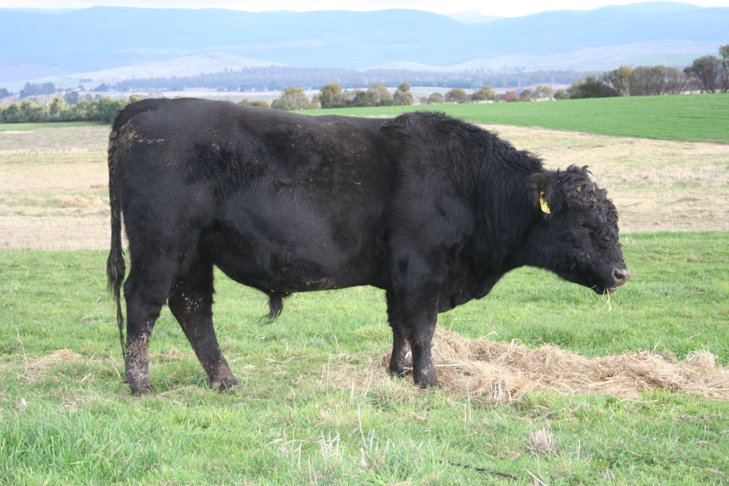Price………… Purchaser……………………….
Tag G38 TDG G38
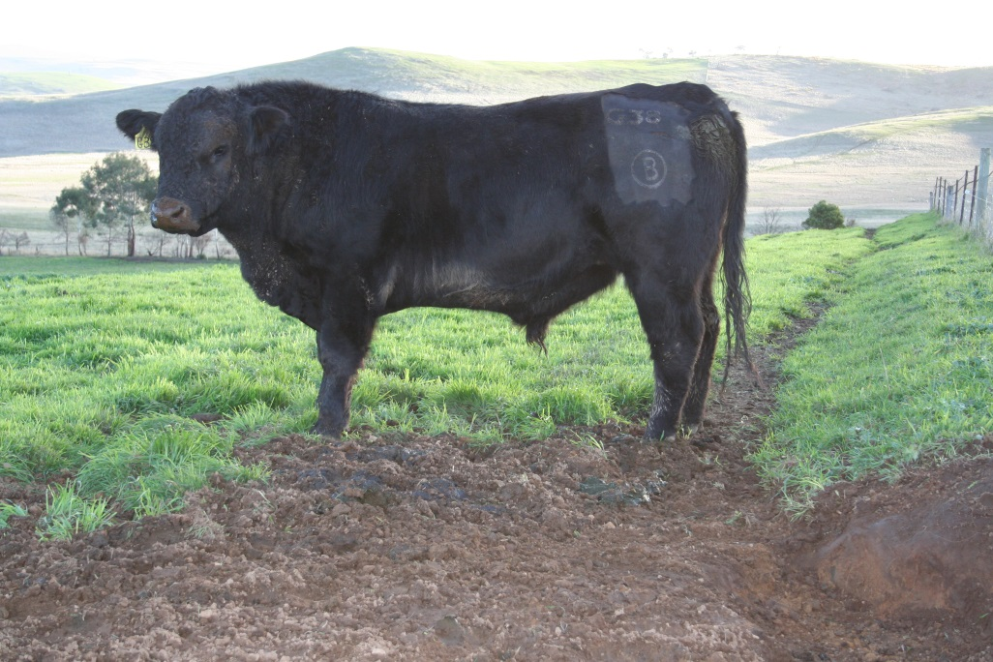
Price………… Purchaser……………………….
Tag G43 TDG G43
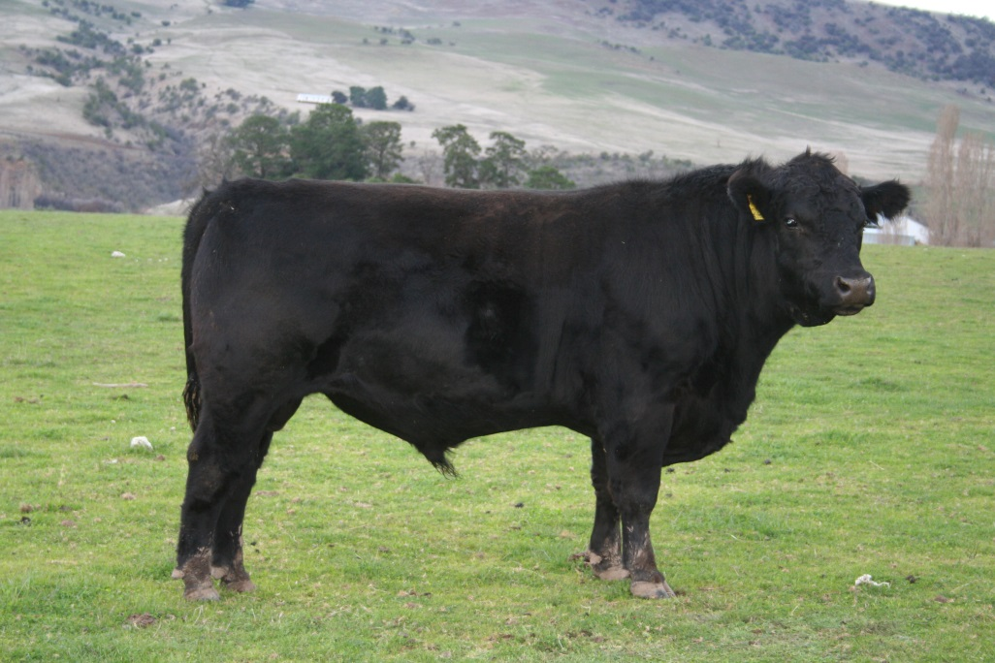Price………… Purchaser……………………….
Tag G47 TDG G47
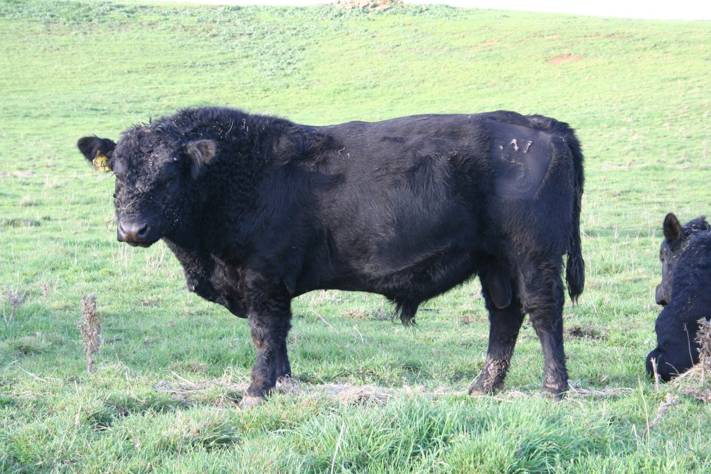Price………… Purchaser……………………….
Tag G52 TDG G52
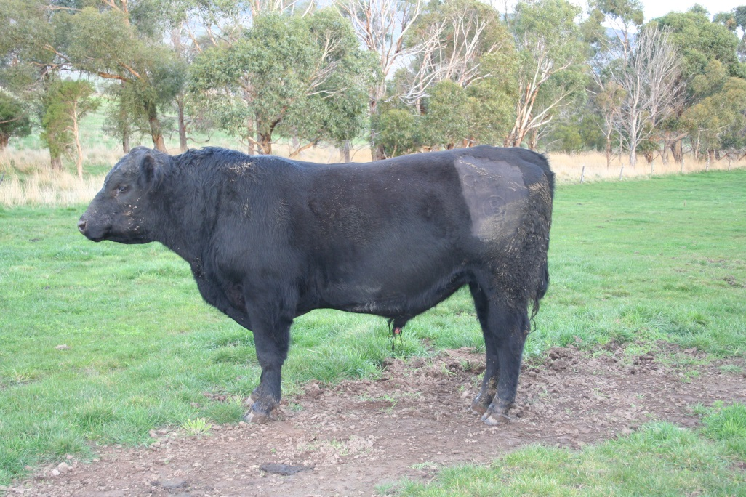Price………… Purchaser……………………….
Tag G58 TDG G58
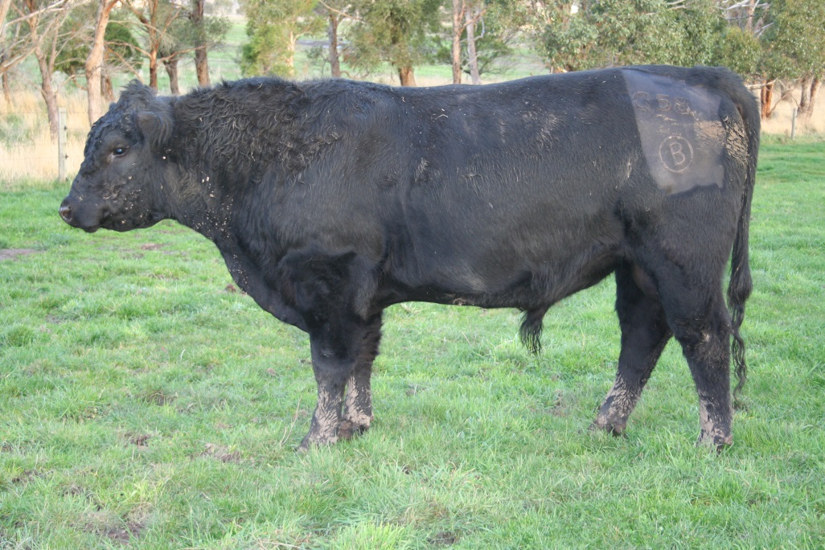
Price………… Purchaser……………………….Tag G77 TDG G77
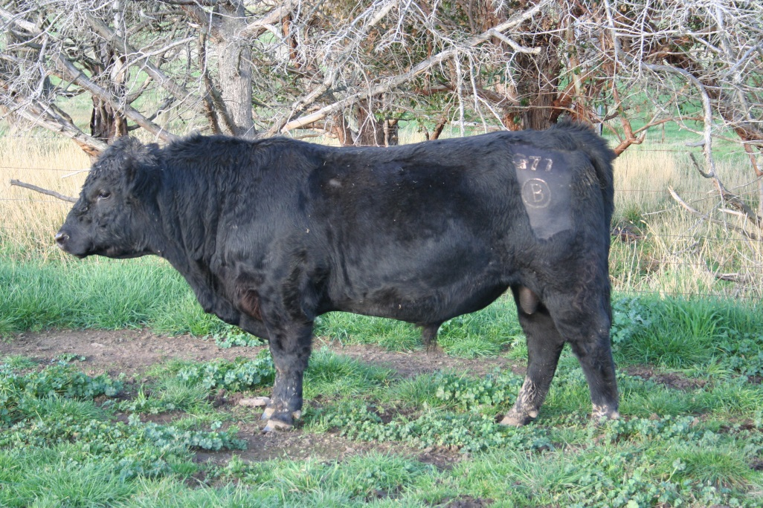
Price………… Purchaser……………………….
Tag G80 TDG G80
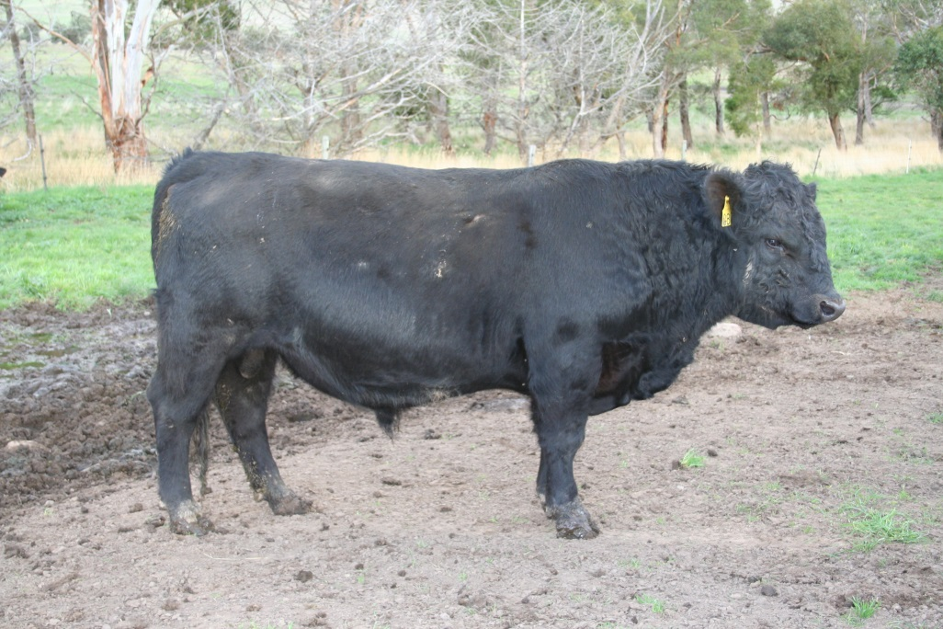Price………… Purchaser……………………….Tag G83 TDG G83
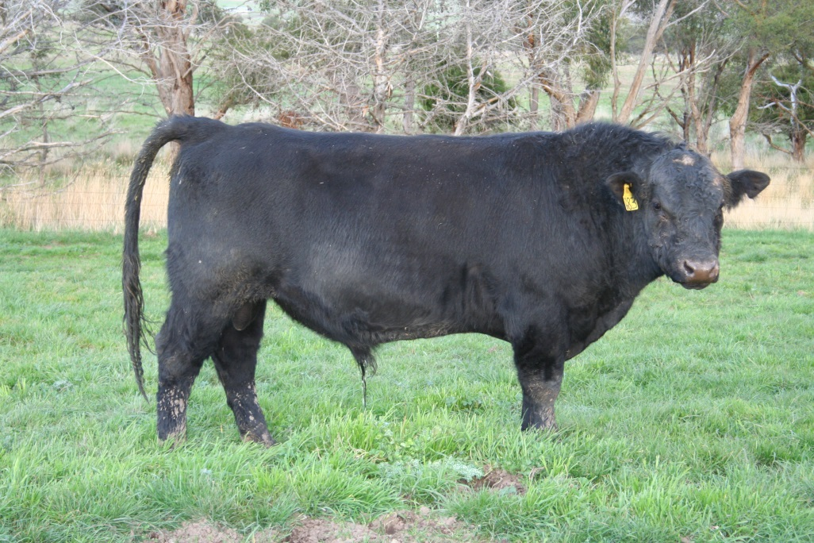
Price………… Purchaser……………………….
Tag G93 TDG G93
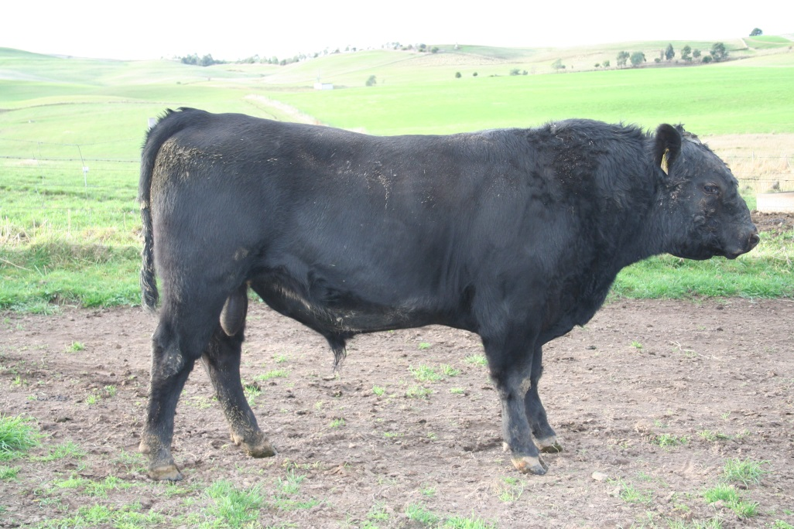
Price………… Purchaser……………………….
Tag G97 TDG G97
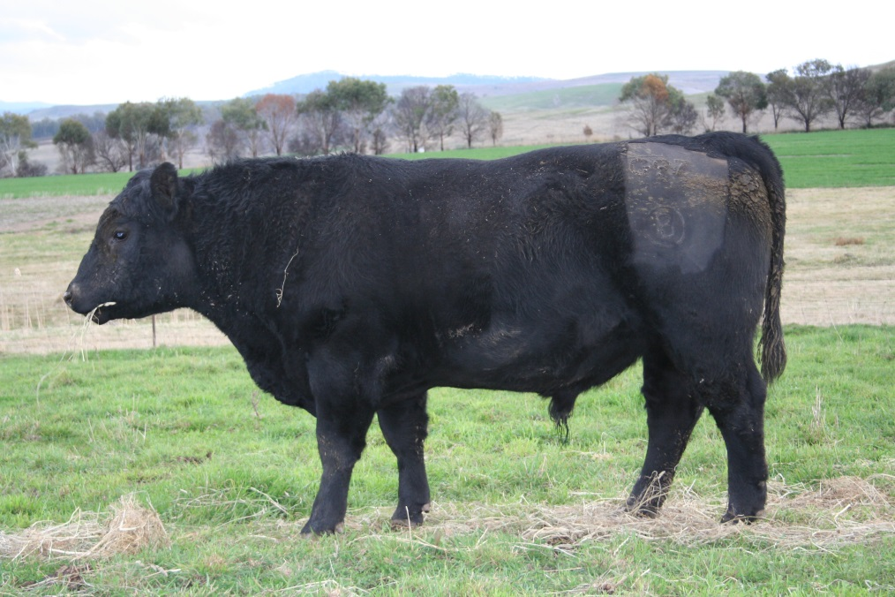Price………… Purchaser……………………….
Tag G99 TDG G99
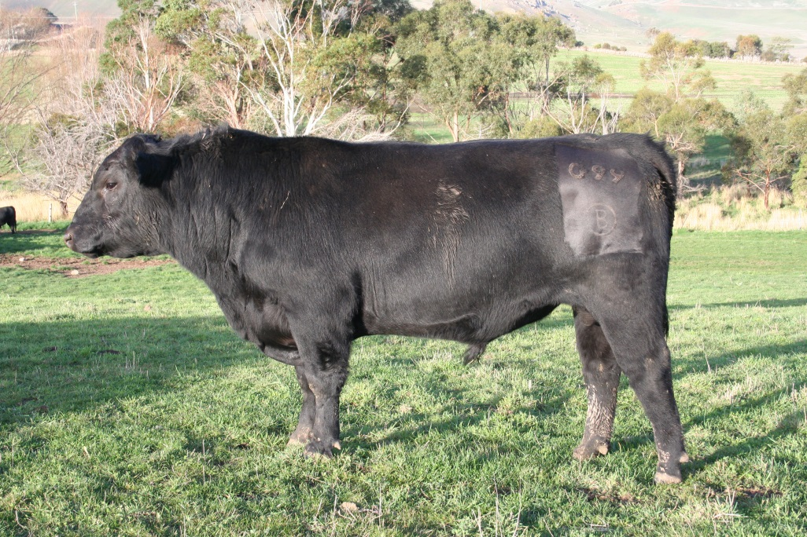Price………… Purchaser……………………….
Tag G128 TDG G128
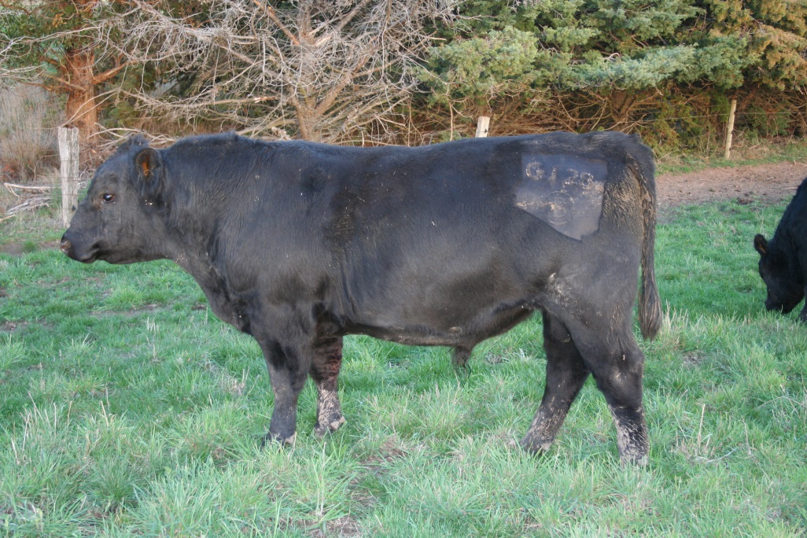
Price………… Purchaser……………………….
Tag F96 TDG F96
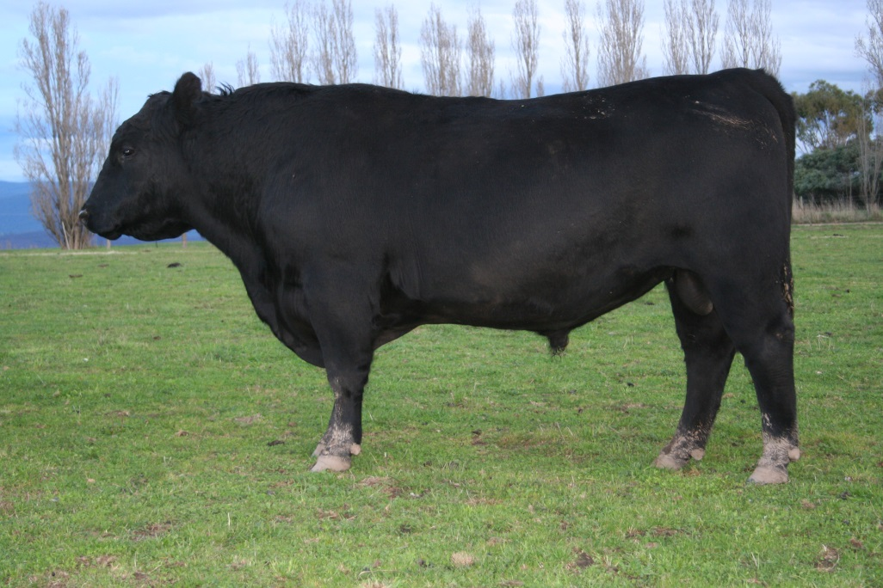 Price………… Purchaser……………………….
Tag F99 TDG F99
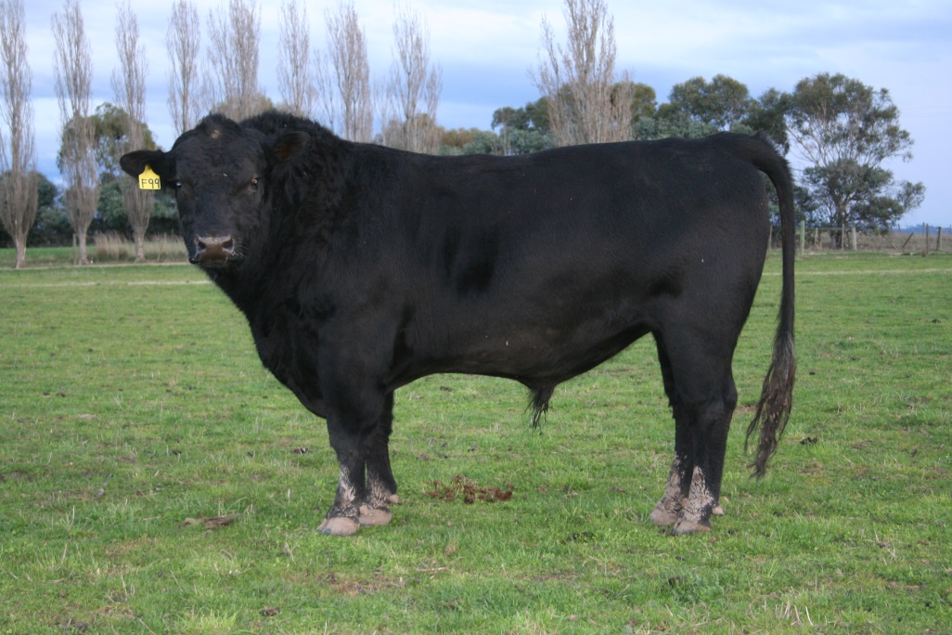Price………… Purchaser……………………….
Tag F127 TDG F127
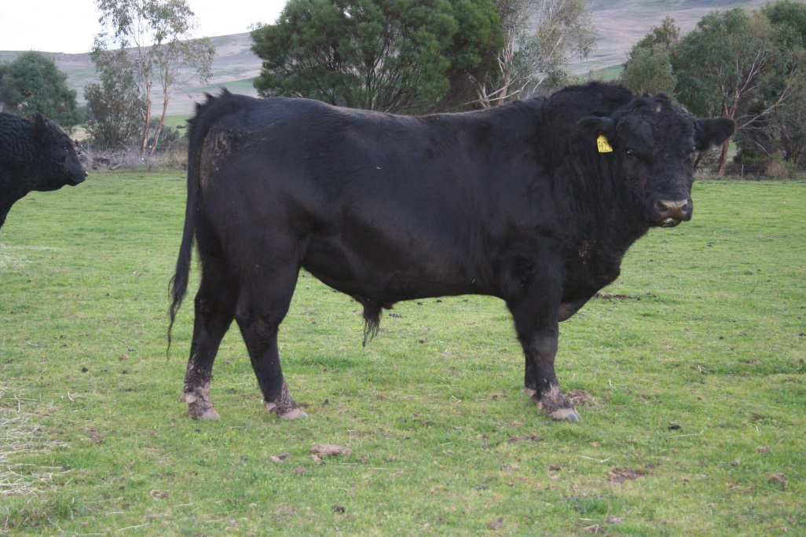Price………… Purchaser……………………….Sires:
Tag B28 TDG B28
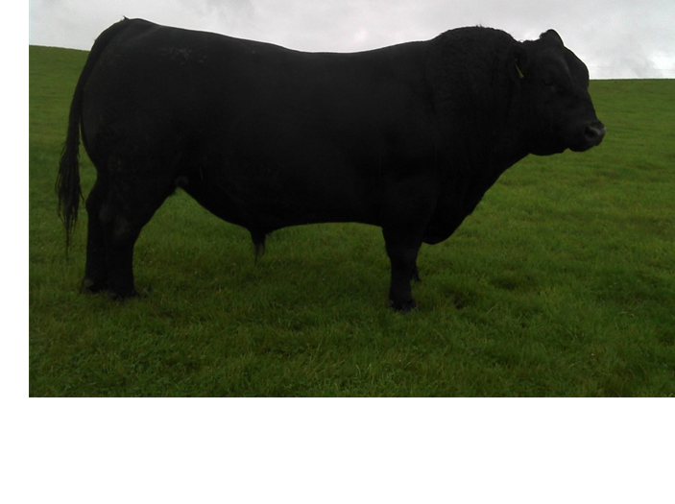
Tag C4 TDG C4
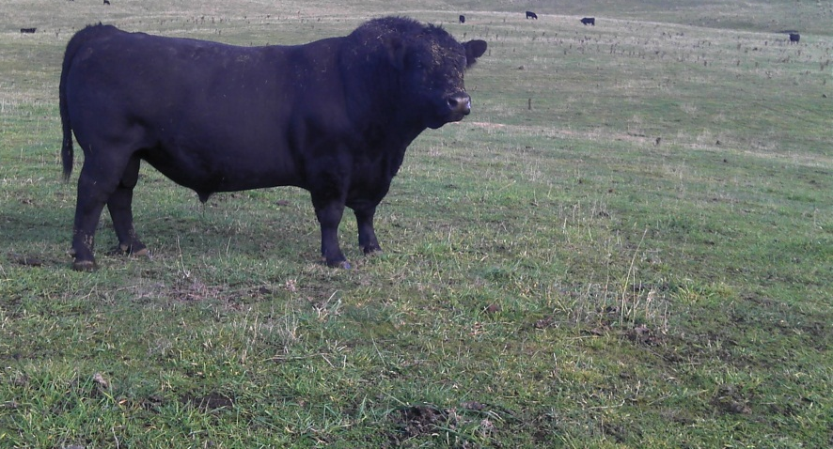
Tag D10 TDG D10
No picture
Tag D17 TDG D17
No picture

Landfall XtractorC312 TFA C312

